Assignment-01

Name: Ravula Muralidhar Reddy

Trainer Name: Harshee Pithroda

Course Name: Python and Machine Learning

Date: 24-05-2022

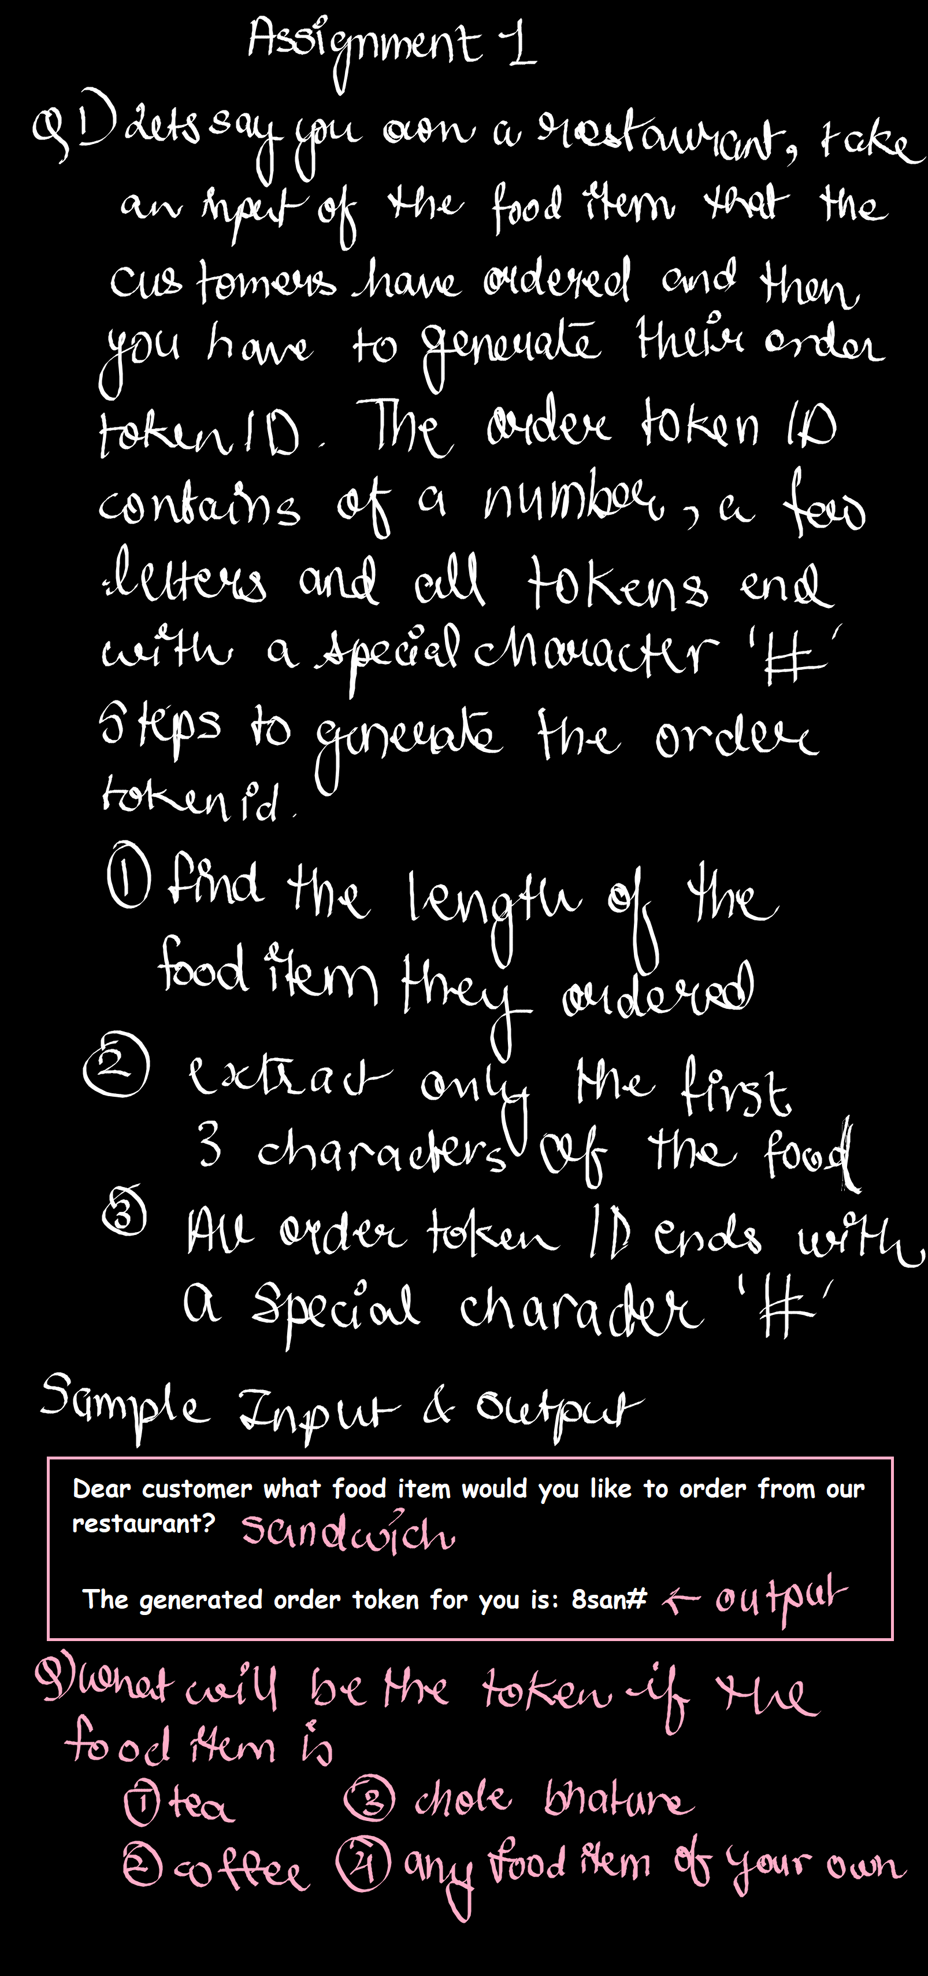

n=input("Dear customer what food item would you like to order from our restaurant?")

l=len(n)

a=n[:3]

b=str(l)+a+"#"

print("The generated order token for you is:",b)

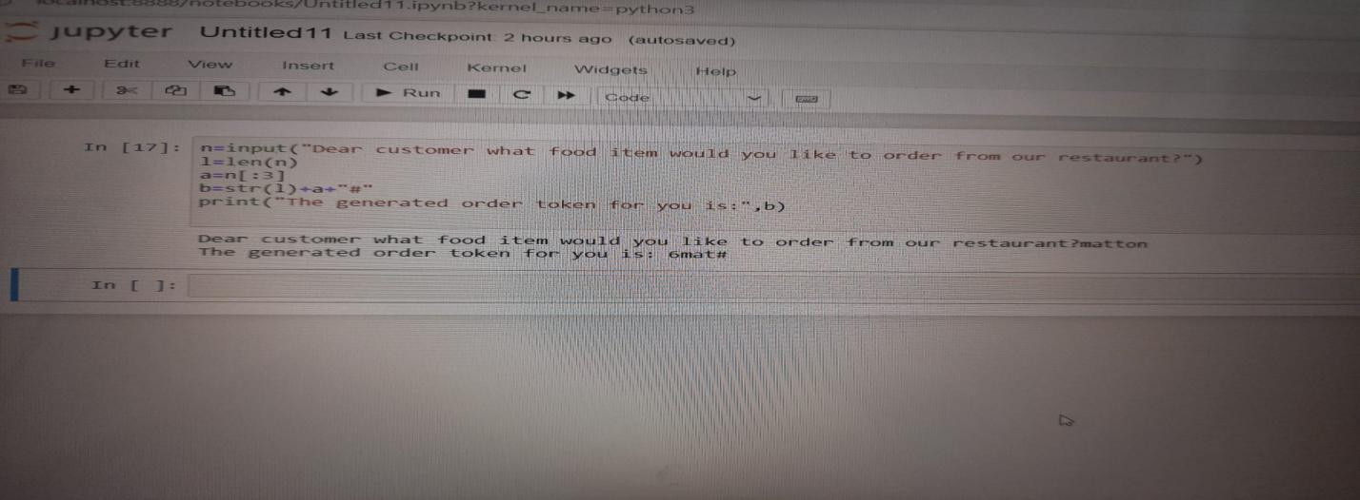

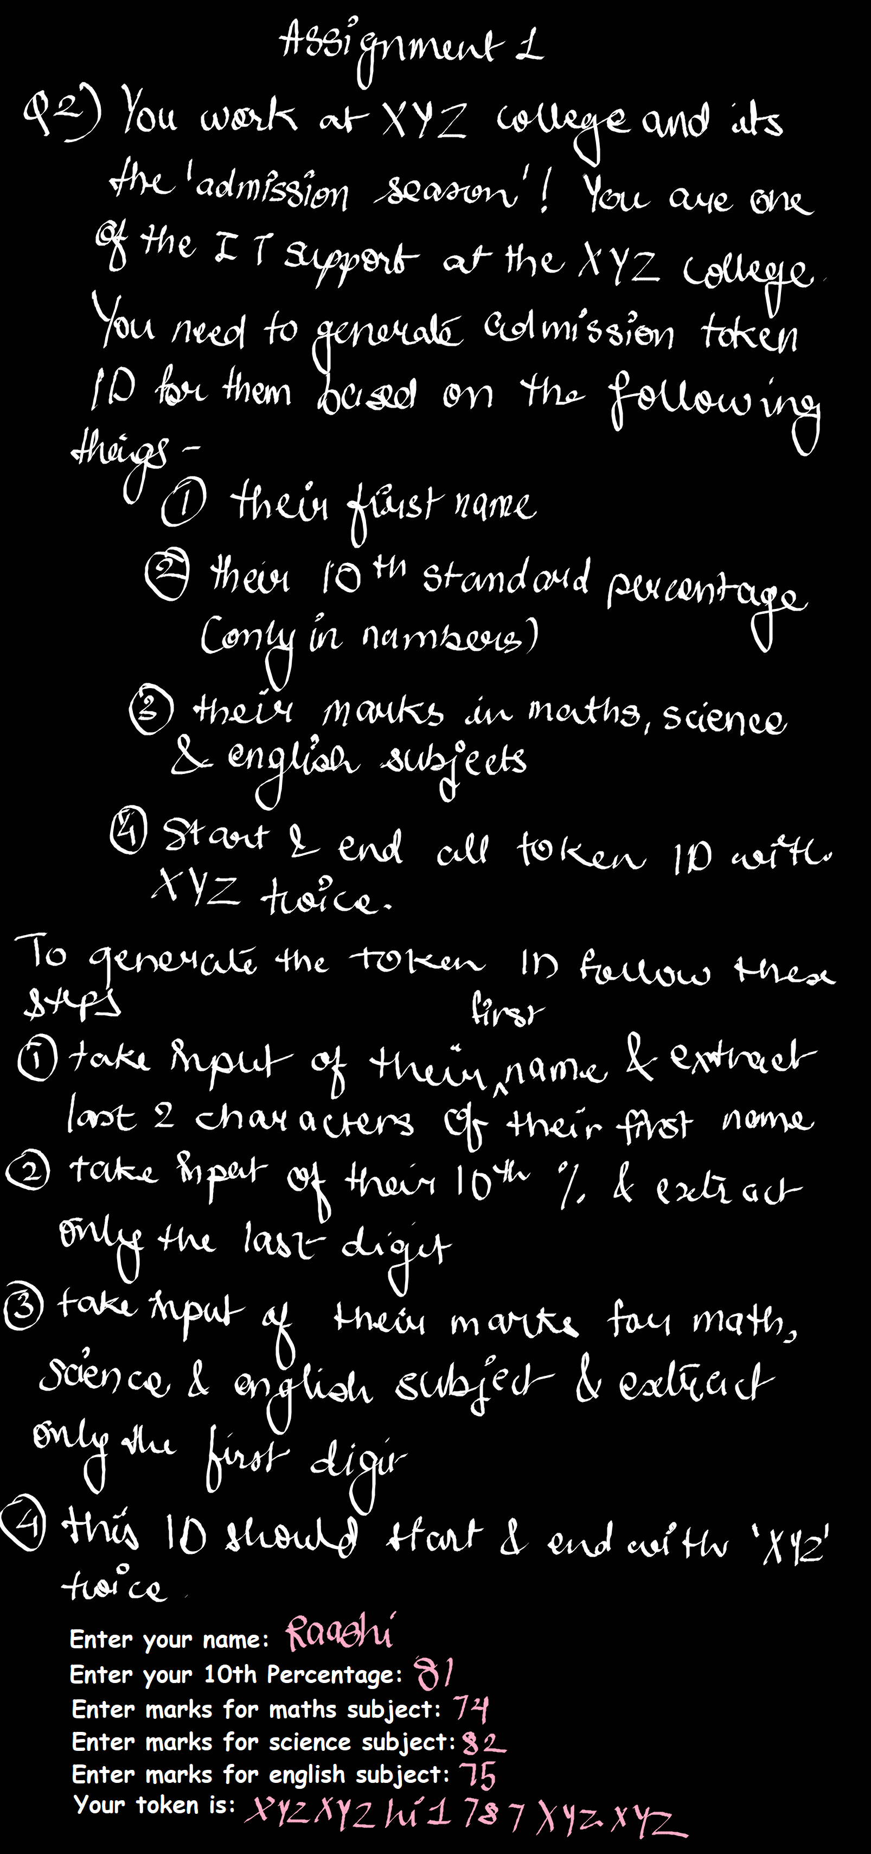

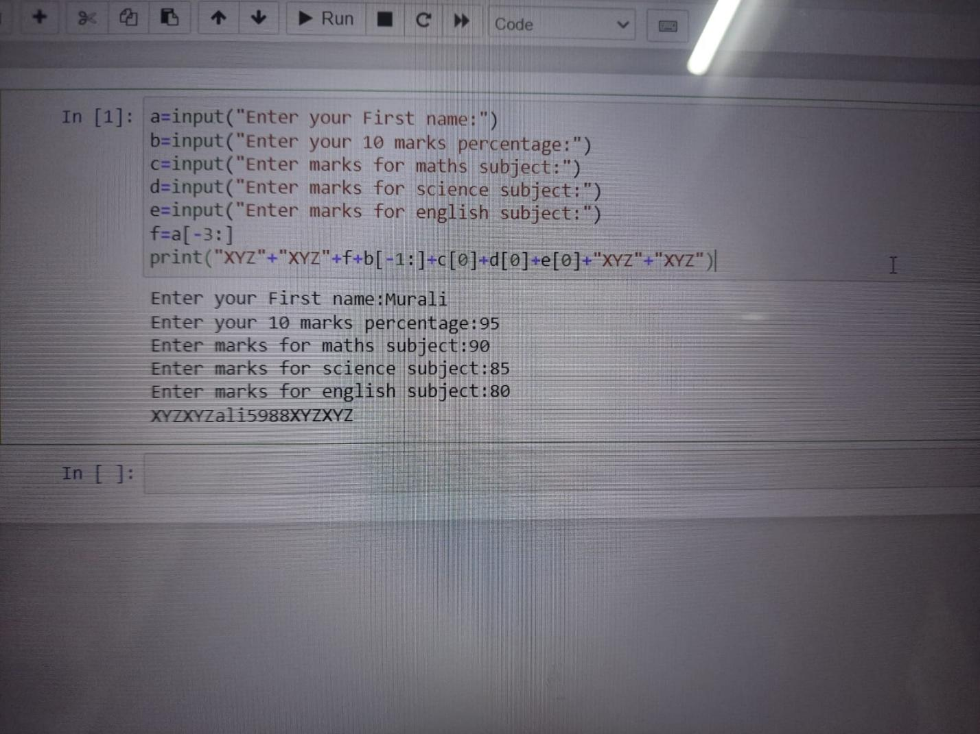a=input("Enter your First name:")

b=input("Enter your 10 marks percentage:")

c=input("Enter marks for maths subject:")

d=input("Enter marks for science subject:")

e=input("Enter marks for english subject:")

f=a[-3:]

print("XYZ"+"XYZ"+f+b[-1:]+c[0]+d[0]+e[0]+"XYZ"+"XYZ")